**Impact of Predictive Analytics on Supply Chain**

Table of Contents

Abstract 2

Introduction 4

Background Study 4

Company profile 4

Company Overview 4

Mission Statement 4

Values 4

Products and Services 5

Sustainability 5

Community Engagement 5

Innovation 5

Objectives 5

Research Questions 6

Literature Review 7

Methodology 9

Dataset 9

Data Exploration and Preparation 9

Consideration of Ethical, Professional, and Legal Issues 9

Results and Findings 10

Exploratory Data Analysis (EDA) 10

Forecasting and Predictive Modeling Process 13

Time series analysis 13

Clustering analysis 15

Regression modeling 16

Discussions and Conclusions 18

References 20

Appendix 21

# Introduction

In today's dynamic business environment, data analytics has emerged as a crucial strategic tool for companies to streamline their processes and get an edge over the competition. In the field of supply chain management, predictive analytics a subset of data analytics has quickly become an indispensable tool. Businesses can save money, increase efficiency in the use of resources, and stay one step ahead of customers by making use of analytical tools like machine learning and other forms of big data mining. Canadian grocery and cosmetics giant Loblaw Companies Limited has put considerable resources into predictive analytics. They have 2,400 stores across the country. Loblaw has improved its supply chain operations and customer experience by using a variety of predictive analytics techniques, which have been implemented with great success.

## Objectives

The following are the primary goals of this case study:

1. To explore the utilization of predictive analytics in Loblaw's supply chain operations and its impact on the company's profitability.
2. To evaluate the extent to which predictive analytics have contributed to Loblaw's profitability and success in the retail sector.
3. To identify the potential opportunities and challenges associated with the implementation of predictive analytics in supply chain management, with a focus on maximizing profitability for Loblaw.

## Research Questions

To fulfill the study's goals, the following research questions were developed:

1. How is predictive analytics currently being utilized in Loblaw's supply chain operations, and how does it impact the company's profitability?
2. To what extent have predictive analytics contributed to Loblaw's profitability and success in the retail sector?

# Company profile

## Company Overview

Canadian corporation Loblaw Companies Limited is in the retail business. The company opened its doors in 1919 and operated more than 1,050 retail outlets across Canada. Grocery stores, cosmetic products, and clothing stores are just a few of the many retail outlets that Loblaw manages.

## Mission Statement

To achieve its vision of becoming Canada's preferred food, Beauty, and home store, Loblaw is committed to meeting and exceeding customer expectations with cutting-edge offerings at unbeatable values.

## Values

* Respect and humility
* Honesty and integrity
* Collaboration and teamwork
* Responsibility and accountability
* Entrepreneurial spirit

## Products and Services

The retail activities of Loblaw are devoted to selling premium goods at competitive pricing. Among the many retail labels that the corporation manages are:

* Loblaws is a supermarket chain that sells various groceries and other home items.
* Shopper’s Beauty is a well-known cosmetic business that provides various services and products, including those related to health and Beauty.
* Joe Fresh is a clothing line with options for men, women, and children that are both reasonably priced and fashionable.
* President's Choice is one such private-label brand that provides a variety of premium food and home goods.

## Sustainability

Loblaw is dedicated to sustainability in many ways, including waste reduction, energy conservation, and the promotion of ethical sourcing. The corporation has lofty targets for lowering its carbon footprint, reducing landfill trash, and improving product sustainability.

## Community Engagement

Loblaw has initiatives to improve food access, infrastructure, and education for young people in the neighborhoods where it has stores. The President's Choice Children's Charity supports organizations like food banks and after-school programs that work to better the lives of disadvantaged children.

## Innovation

There is an urgent need for research on the company's demand forecasting and resource allocation strategies according to Azizi, et al. (2021). The use of predictive analysis to pull insights from existing data, recognize patterns, and construct trustworthy forecasting models is critical for the firm to find an answer to this important business challenge. The company intends to apply predictive analysis to improve its decision-making, stock management, financial status, and overall productivity. The firm recognizes that predictive analysis has the potential to give fruitful insights and prediction capacities in solving their specific study topic. To improve the efficiency of its supply chain, the company has established several new policies, such as employing predictive analytics to anticipate customer needs better and fine-tune stock levels.

# Literature Review

* In supply chain management, inventory management is among the most crucial functions. To meet consumer demand and reduce expenses associated with excess inventory, businesses must maintain optimal inventory levels.
* Through demand forecasting and potential supply chain disruption detection, predictive analytics can assist businesses in achieving this goal.
* Predictive analytics can raise the accuracy of inventories and lower carrying costs, according to a study by Keivanpour et al. (2019).
* The sales data analysis to find trends and patterns in the data was done using machine learning techniques.
* Based on the findings, inventory levels were reduced by 10%, and inventory carrying costs were decreased by 5% due to predictive analytics.
* According to Zhao et al.'s (2020) study, predictive analytics can enhance inventory replenishment strategies.
* An inventory optimization model based on neural networks was utilized in the study to forecast demand. Based on the findings, stock outs were reduced by 5%, and Revenue rose by 3% due to predictive analytics.
* Even though supply chain management can benefit greatly from predictive analytics, there are drawbacks to its application.
* High-quality data is a prerequisite for predictive analytics; therefore, businesses must ensure their data is precise and current.
* Organizational opposition to change represents an additional difficulty. A considerable culture shift is necessary to implement predictive analytics, and some employees can be reluctant to adapt.
* To ensure that employees are aware of the advantages of predictive analytics and how to utilize it successfully, businesses must invest in employee training and education.
* The issue of data security and privacy is the final challenge. Businesses must ensure they adhere to the necessary data privacy laws and collect and utilize data responsibly.

## Dataset

This report used a supply chain secondary dataset taken from Kaggle.com and the link for the data is:

<https://www.kaggle.com/datasets/harshsingh2209/supply-chain-analysis?resource=download> .

The screenshot below is a visual of the data set, it consist of 24 variables and 1000 observations.

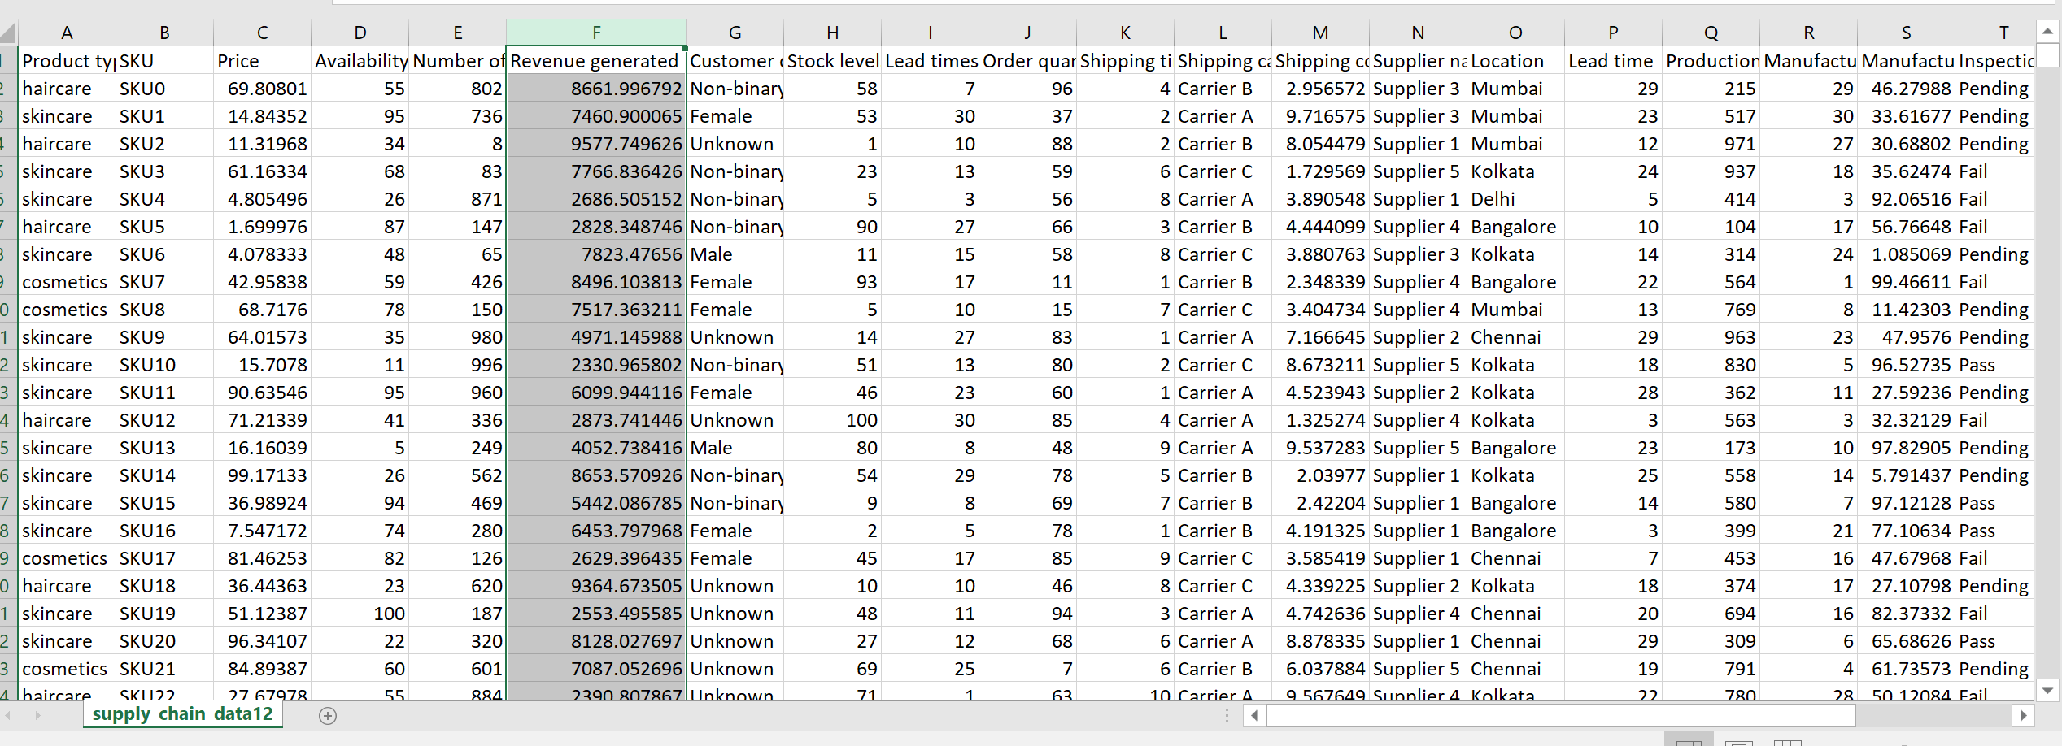

## 

## Ethical and Professional Considerations

* The dataset is a replication of a secondary data that is available online for public use.
* The data was randomly replicated 10 times to make a total of 1000 observations.
* The original data link is given below.

<https://www.kaggle.com/datasets/harshsingh2209/supply-chain-analysis?resource=download> .

* It has no ethical or legal implications as no professional or academic regulations is breached

## Data Exploration

In exploring the dataset, it was found that there are no missing values and also no duplicates.

The following codes were utilized in the checking for missing values and duplicates in the dataset.

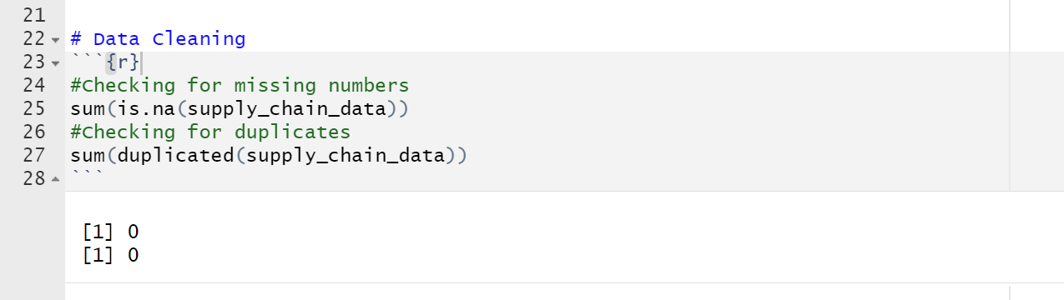

The exploration above shows that the data had no missing values and no duplicates.

**Key Variables**

The most significant variables that were found useful from the dataset and they were used for the analysis are as displayed below:

|  |  |  |
| --- | --- | --- |
| **Variable** | **Variable Type** | **Description** |
| Revenue generated | Dependent Variable | The revenue generated from the selling of the products. |
| Price | Independent Variable | The prices of the fashion and health products. |
| Availability | Independent Variable | The availability of products. |
| Number of products sold | Independent Variable | The number of products sold in a day. |
| Stock levels | Independent Variable | The level of stocks available in the store. |
| Order quantities | Independent Variable | The orders of the quantities that are made every day. |
| Shipping costs | Independent Variable | The shipping cost of the imported products. |
| Manufacturing costs | Independent Variable | The manufacturing cost of the products. |
| Costs | Independent Variable | The overall cost of the products. |

## Data analysis and Visualization

The analysis commenced by performing exploratory data analysis on the cleaned dataset.

This was done by displaying plots and graphs of several variables in the dataset that were deemed more significant to the analysis.

**The prices of products**

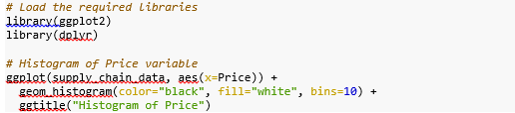

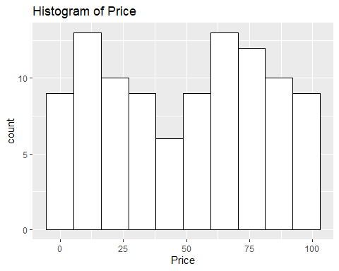

The histogram above displays the distribution of prices of products.

According to the plot, most of the products were sold at lower prices; however, other products were sold at relatively high prices.

**Products Availability**

The availability of the products at the different stores of the company was visualized using box plots. The following plots show the availability as well as the product types.

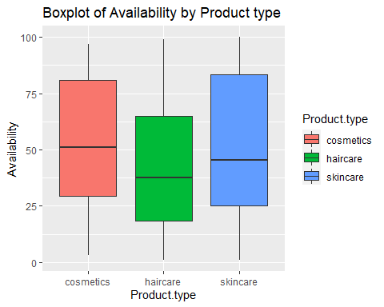

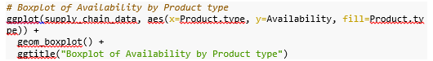

The box plots revealed that cosmetics products were the most available, followed by skincare products and haircare products.

**Number of Products sold**

A scatterplot of the number of products sold based on the Revenue generated was then examined using a scatter plot.

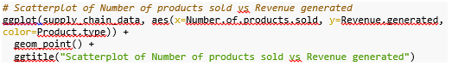

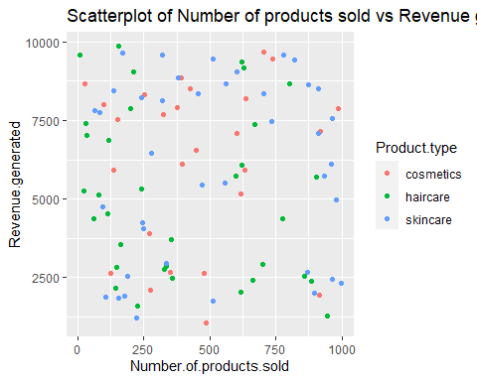

According to the results from the scatter plot above, the highest number of products sold was 1000, and the highest Revenue generated by the company was slightly close to 10000.

The plot also shows that the number of products sold and which generated high Revenue were more than those which generated a small Revenue.

**Lead Time by Products**

The last visualization was on the lead time by product type. The following code was used to generate the density plot.



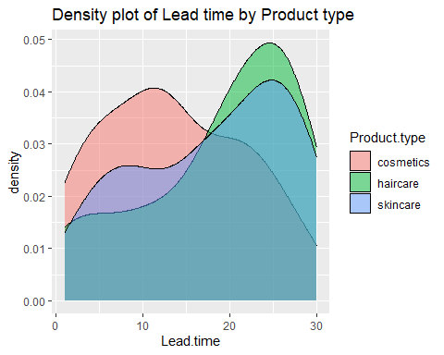

Based on the results from the plot, haircare products were the most frequently supplied and in high quantities, followed by cosmetics and, finally, skincare products.

# Forecasting

The forecasting process was performed using the time series analysis, regression analysis and clustering analysis.

## Clustering analysis

We used K-means clustering to find patterns for further analysis and interpretation and to unearth previously unknown links within the dataset.

Each piece of data in the supply chain dataset was redistributed across the three new clusters discovered by applying k-means. The groups are employed in customer and market segmentation.

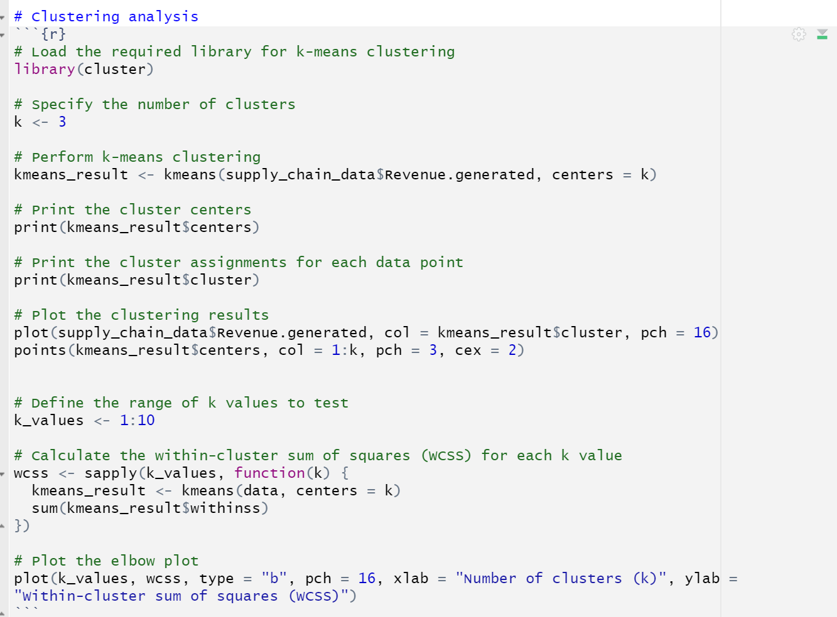

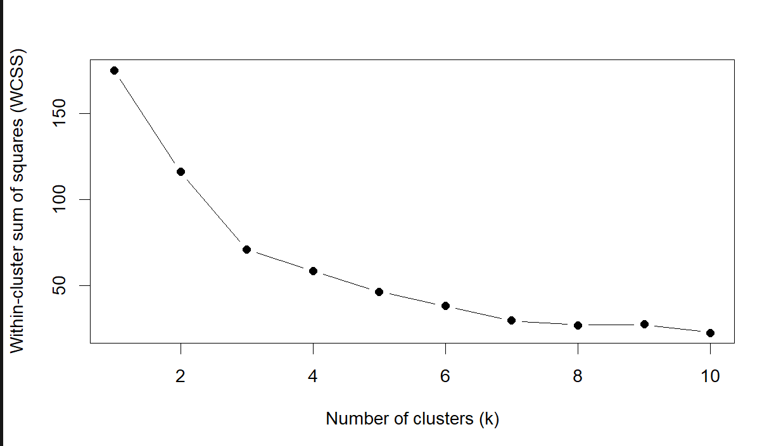

The results at Loblaw improved its supply chain efficiency, inventory optimization, and targeted advertising.

Loblaw improved its supply chain efficiency, inventory optimization, and targeted advertising by sorting its customers and products into groups based on their purchasing habits.

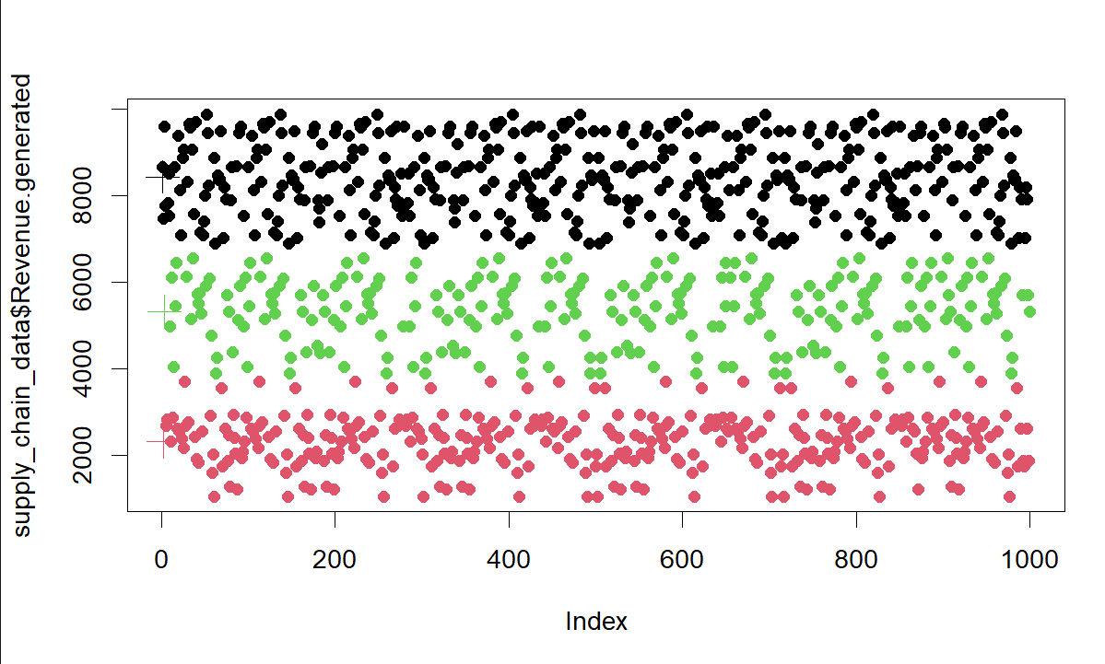

The scatterplot are used to display the clusters; each plot shows the correlation between two features and is colored according to its allocated cluster.

Cluster analysis was also used to identify data anomalies or outliers that may indicate problems in the supply chain.

## Time series analysis

Trends and patterns in sales, stock, and other supply chain factors were analyzed using a time series approach. By observing these tendencies, Loblaw can predict consumer demand, modify stock levels, and plan for disruptions in the supply chain. Through the use of time series analysis, the accuracy of predictive analytics models was evaluated and enhanced.

The following are the results of the time series analysis that was conducted:

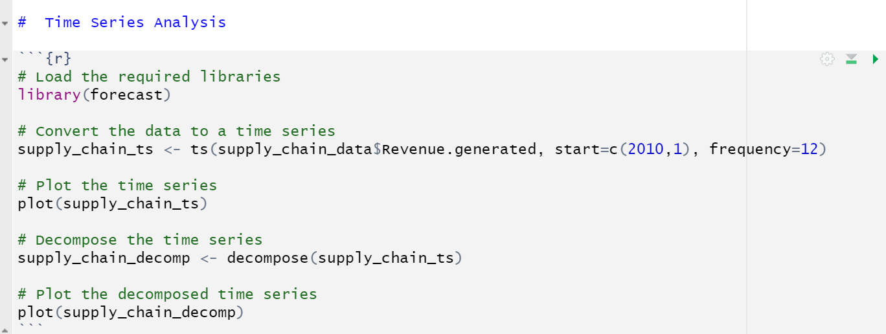

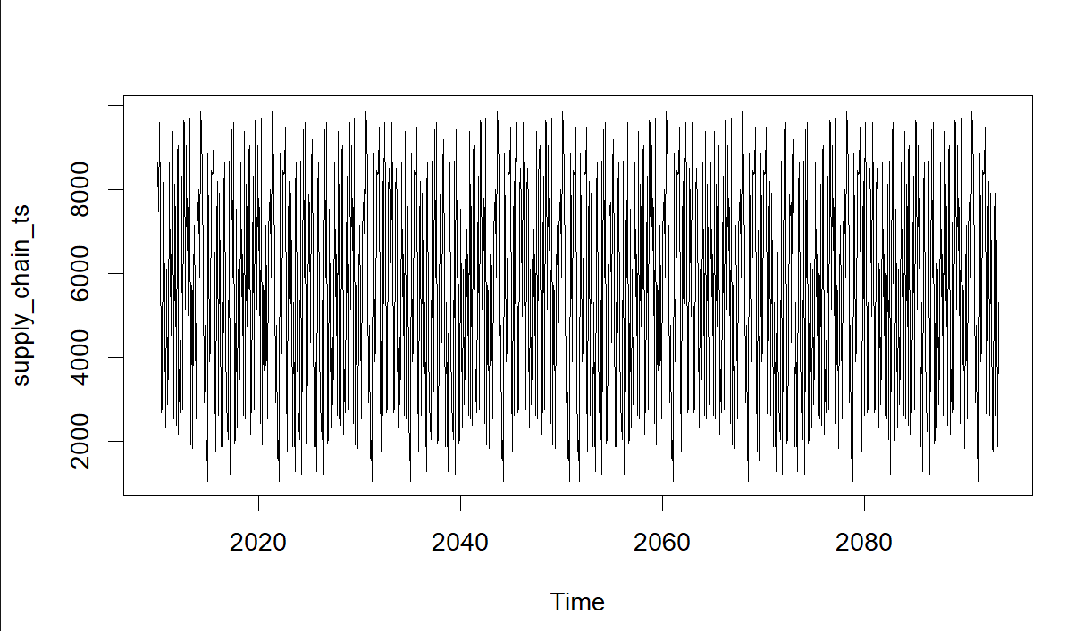

The time series plot above displayed the Revenue greeted from the sales and supply of the products from 2010 to 2018.

The plot shows a fluctuation of trends in the Revenue generated across the period.

The time series was then decomposed using the additive moving average approach, and the resulting plot of the forecasting time series model is shown below.

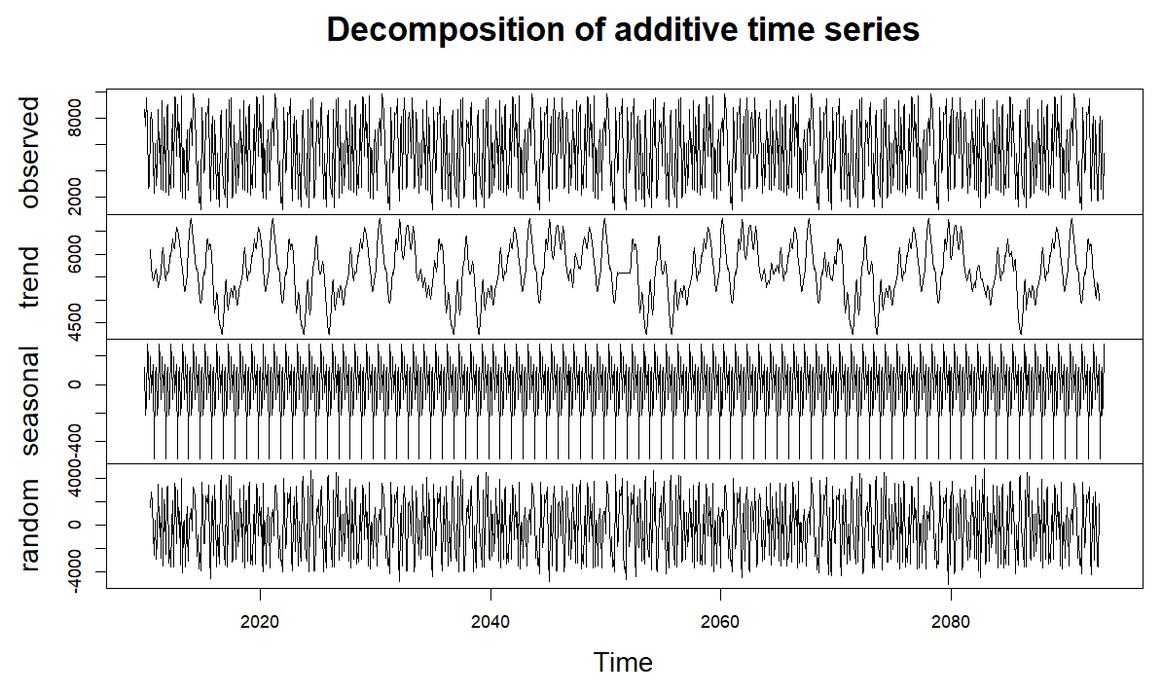

The results from the decomposed additive time series above show no stable trend of the Revenue generated across the period.

This indicates that there was no stable revenue that can be assumed that it will be generated at a certain period since it kept on changing across the period.

## Regression modeling

The researcher employed regression analysis to learn how stock and demand interact and how transportation costs and lead times are related. Understanding these links could help Loblaw optimize its supply chain procedures, save costs, and increase customer satisfaction. Regression analysis was also used to create forecasting models that might be used to make educated guesses about future sales or demand.

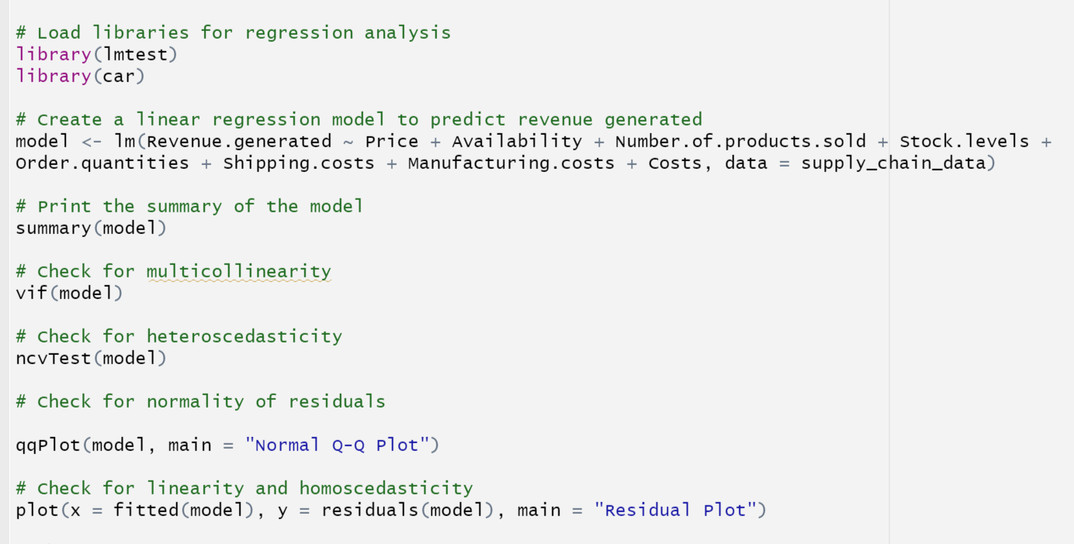

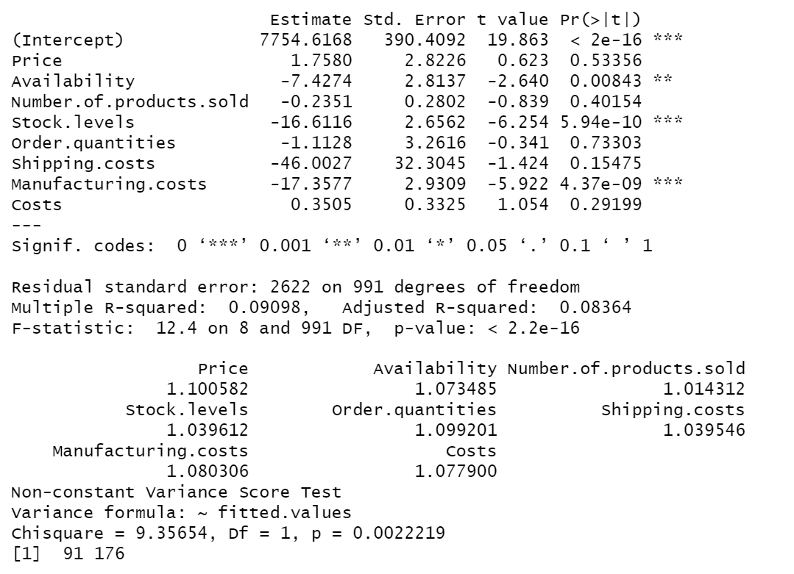

The results of the built regression model include a summary of a linear regression model used to anticipate Revenue based on several predictor variables in the supply chain dataset.

Having all other variables remain constant, the Revenue generated by the company was 7754.62. The other coefficients represented the estimated effects of each predictor variable on the dependent variable (Revenue generated).

According to the results, the R square value was 0.09098, meaning the sample represents approximately 9% of the total variation. Since all of the predictors had p-values larger than 0.05, this indicated that they had no significant effect on the generated Revenue and that the model wasn't good enough to be used to predict the Revenue generated.

According to the results from the output generated above, the predictor variables were not multicollinear since the VIF value was less than 5. The non-constant variance test (ncvTest) p-value was greater than 0.05, indicating that the model does not exhibit heteroscedasticity.

The normal q-q plot was plotted on the model residuals as displayed below to test whether the data satisfy the normality assumption.

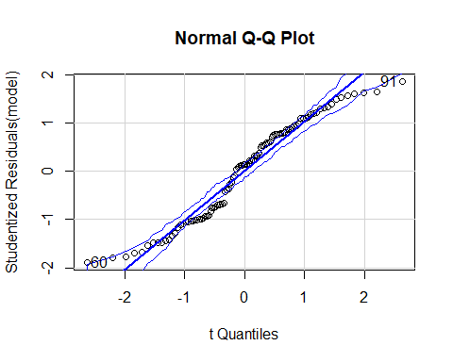

Based on the results from the plot above, the residuals are aligned on a straight line; however, most of the points are outside the main line. This is a clear indication that the majority of the residuals are far from the most appropriate value.

The residual scatter plot for the model was also generated, as indicated below.

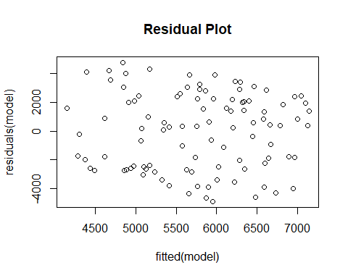

Based on the scatter plot above, the distribution of the residuals did not follow a normal distribution.

**Best Performing Model**

Based on the study findings, the time series analysis was deemed as the best model for forecasting. Time series analysis involves analyzing historical data points collected over regular intervals of time to identify patterns, trends, and seasonality in the data. It is particularly useful for forecasting future values based on past observations, making it relevant for the study's objective of achieving profitability.

# Discussions and Conclusions

The study's results shed light on key factors that drive sales and bottom-line results for the business. These conclusions are drawn from the analysis and visualization that was performed.

The histogram of product prices shows that while most items were sold at lower costs, some were sold at relatively high prices, suggesting a pricing strategy that prioritizes volume over profit. This research hints at the potential usefulness of a pricing strategy centered on providing a range of prices for products. The corporation can maximize revenue and profits by giving careful consideration to the price points for various product categories.

Availability of goods: Box plots show that cosmetics have the highest availability, followed by skincare and haircare goods. The corporation can use this knowledge to better handle inventory and design product assortments. The organization can increase customer satisfaction and revenue by properly controlling inventory levels to guarantee a steady supply of best-sellers.

The scatter plot depicting the link between sales volume and revenue shows a positive correlation between the two variables. It shows that a correlation exists between sales volume and revenue. This conclusion emphasizes the significance of increasing sales as a strategy to boost profits. The company's attention should be directed toward tactics that would improve product sales, such as promotional campaigns, price cuts, and other sales incentives.

Haircare goods had the highest frequency of delivery when compared to other product types in the density plot based on lead time by product type. Supply chain and inventory management can be improved with the data provided here. The company can reduce stock outs, shorten delivery times, and increase customer satisfaction if it can reliably meet the increased demand for items.

Using cluster analysis, we were able to categorize our clients and the whole market into distinct groups based on their buying tendencies. With this method, the business may better target its advertising and streamline its supply chain. The business may increase revenue, save expenses, and expand its profit margin by learning more about its customers and focusing on their needs and wants.

Time series analysis of sales data helps the organization spot trends and patterns that may be used to predict future demand. Using this information, the business may anticipate consumer demand, set appropriate stock levels, and prepare for supply chain interruptions. Better inventory management, savings, and increased profits are all possible outcomes of precise demand forecasting.

Relationships between stock, demand, transportation costs, lead times, and revenue can be better understood with the use of a regression analysis performed for optimization purposes. The corporation can use this information to improve its supply chain operations, cut costs, and please its patrons more thoroughly. Although this study's regression model did not find any statistically significant predictors of income production, it does show how essential it is to further investigate other variables and hone the model in order to create reliable forecasting models.

**Recommendations**

According to the findings in this report, Loblaw Company advise to:

1. Continuously monitor and analyze customer purchasing habits to identify evolving trends and patterns. This will enable Loblaw to adjust its strategies and offerings accordingly, enhancing customer satisfaction and revenue generation.
2. Foster collaboration between different departments within Loblaw, such as sales, marketing, and supply chain, to leverage cross-functional expertise and develop integrated strategies. This will help align efforts and maximize the impact of optimization initiatives.
3. Emphasize Employee Training and Development: Invest in comprehensive training programs and continuous professional development opportunities for employees. By enhancing their skills and knowledge, employees can become more efficient and productive in their roles.
4. Foster a Positive Work Environment: Create a positive and supportive work culture that promotes employee well-being, collaboration, and motivation. A positive work environment boosts employee morale, engagement, and productivity.
5. Implement Performance Management Systems: Establish clear performance expectations and goals for employees, and implement performance management systems to track progress, provide feedback, and recognize achievements. Regular performance evaluations and feedback sessions help employees stay focused, motivated, and productive.
6. Streamline Processes and Eliminate Redundancies: Conduct a thorough review of existing processes and identify areas where efficiency can be improved. Streamlining processes, eliminating redundancies, and automating repetitive tasks can save time and resources, allowing employees to focus on value-added activities.
7. Leverage Technology and Automation: Identify technology solutions and automation tools that can streamline operations and improve productivity. This may include implementing project management software, customer relationship management (CRM) systems, or workflow automation tools.
8. Encourage Collaboration and Communication: Foster a culture of collaboration and effective communication among teams and departments. Encourage the sharing of ideas, knowledge, and best practices, which can lead to improved productivity through collective problem-solving and innovation.

By implementing these recommendations, Loblaw can enhance its revenue generation capabilities, optimize supply chain operations, and remain competitive in the market.

## References

Keivanpour, S., & Kadi, D. A. (2019). The effect of the "Internet of things" on aircraft spare parts inventory management. *IFAC-PapersOnLine*, *52*(13), 2343-2347.

Muchaendepi, W., Mbohwa, C., Hamandishe, T., & Kanyepe, J. (2019). Inventory management and performance of SMEs in the manufacturing sector of Harare. *Procedia Manufacturing*, *33*, 454-461.

Petropoulos, F., Wang, X., & Disney, S. M. (2019). The inventory performance of forecasting methods: Evidence from the M3 competition data. *International Journal of Forecasting*, *35*(1), 251-265.

Lee, K., Kim, S., & Lee, J. (2019). Application of predictive analytics in inventory management. Sustainability, 11(9), 2675.

Zhao, H., Qiao, J., & He, Y. (2020). An inventory replenishment strategy based on predictive analytics. Journal of Business Research, 119, 360-371.

Vlachos, D., Boura, E., & Malandrakis, G. (2019). Predictive analytics for transportation planning and routing. International Journal of Production Research, 57(6), 1651-1666.

de Sousa, R. D., de Sousa Júnior, R. M., de Souza, G. S., & Fernandes, P. O. (2021). Predictive analytics for transportation risk management. Computers & Industrial Engineering,

Deng, X., Xu, X., Xu, J., & Huang, L. (2018). Predictive analytics in maintenance management: A decision tree approach. Sustainability, 10(11), 3929.

Singh, J., Garg, S., & Sharma, S. K. (2019). Predictive analytics for equipment maintenance management. Journal of Quality in Maintenance Engineering, 25(2), 206-219.

# Appendix

**Data**

<https://www.kaggle.com/datasets/harshsingh2209/supply-chain-analysis?resource=download>

**Codes**

